NRA to NLKF updating principles

**Purpose**: This document outlines how are the NAP Level of Service KPI Framework (NLKF) Key Performance Indicators (KPI) present in the NAP Reference Architecture (NRA) and how they are being updated.

**Audience**: NRA maintenance team

# Modelling of the NLKF KPI as NRA KPIs

The individual NLKF KPI are transferred into the Enterprise Architect (EA) model of the NRA to the “**Supplements\KPI framework**” folder as NRA KPIs. Each NRA KPI group is in a separate subfolder with a view representing the individual NRA KPIs.

The NRA KPIs are modelled as “requirements” (by a requirement class). They impose a requirement to the NRA; they are connected to the objects defined in the NRA.

The NRA KPI group View is versioned and linked to a NLKF resource

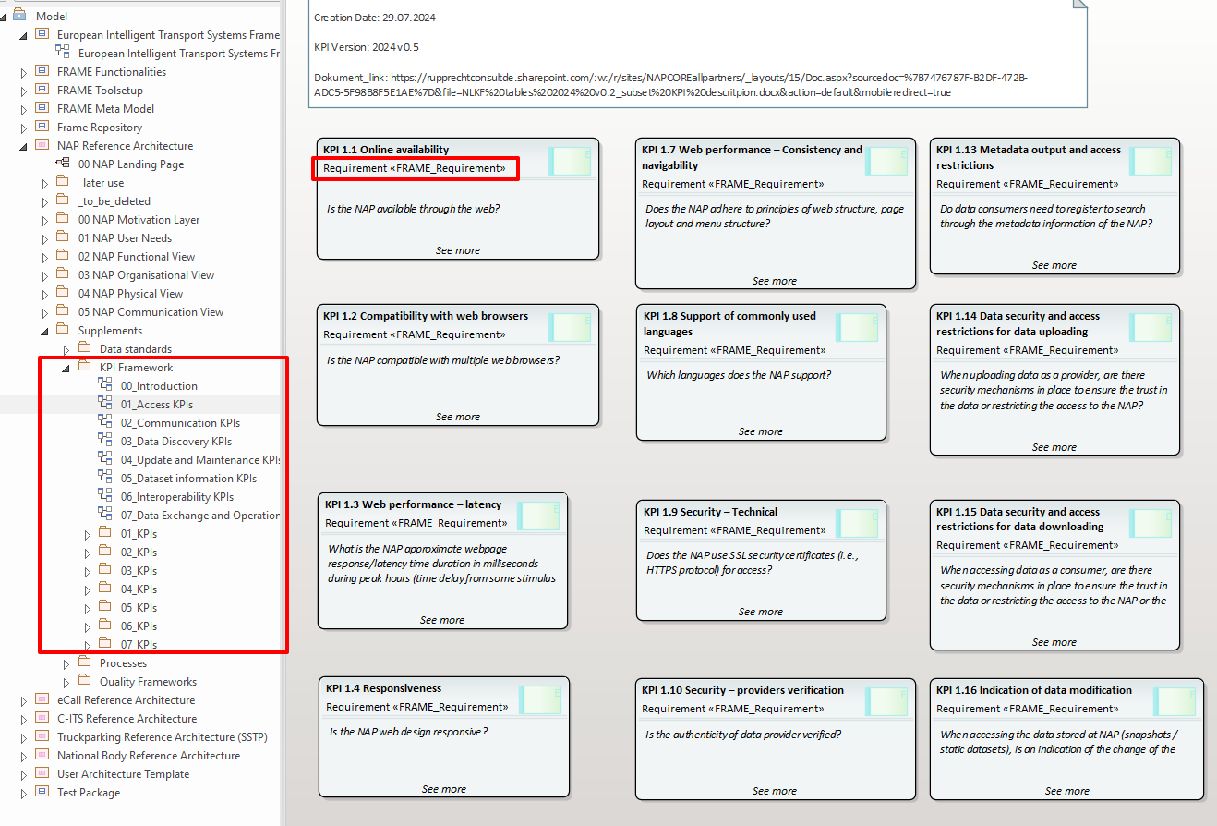

Figure 1 Screenshot of the EA tool with transferred KPIs

NLKF KPI is modelled in NRA tool as NRA KPI, with these features:

* (1) ID and Name
* (2) Description
* (3) Choices
* (4) Minimum agreed level of the KPI to achieve interoperability
* (5) version of the NLKF Framework (a date, e.g., 20240821)

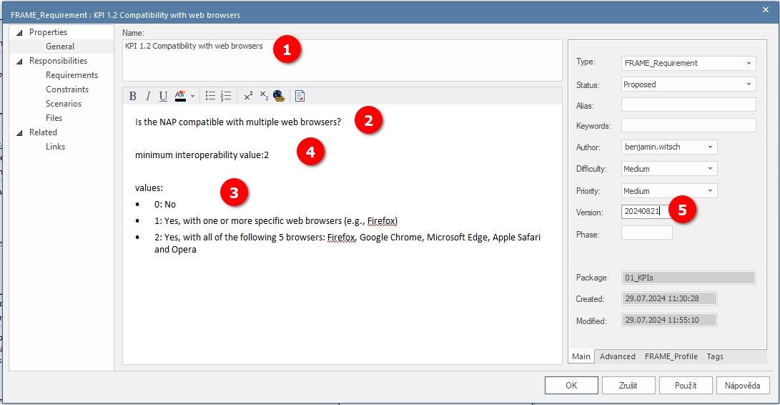

Figure 2 Screenshot of the KPI definition in the EA

# Mapping NRA KPIs

Mapping of the NRA KPIs follows several rules:

* To avoid all-to-all connection, high-level NRA objects are selected for mapping in precedence to low-level NRA objects. Low-level objects are selected only if the condition could not be satisfied at the higher level, i.e. the condition does not apply for all lower-level objects included in the higher level one. This is done in this order:
  1. Subsystem (component)
  2. Module (application)
  3. Interface
  4. Function/datastore
  5. Any other object
* Most of the KPIs are mapped to the physical or communications view objects. This is because many KPIs impose requirements for the physical instance (an installed system).
* If the KPI minimum level of acceptance is “no feature” then the KPI is not mapped to anything.
* While mapping, the NRA object definition is analysed for a textual change and ONLY where absolutely necessary, for clarity reasons, some excerpts from the KPI definition are added to the mapped NRA object definition.
* While mapping, the definitions of all NRA objects are checked not to contradict the KPI in question. If this happens either:
  1. Edit the text of the NRA object not to contradict
  2. Trigger the change of the NLKF KPI if the contradiction is in the favour of the NRA.
* Mapping the KPI to NRA object serves as a requirement for that object. The mapping is NOT DONE on the basis of textual similarity or appearance of some of the KPI definition in the NRA object.

# Linking NRA KPIs

Linking of the NRA KPIs to the NRA objects is done in following way:

1. Copy and paste the NRA KPI as a link to the view where NRA objects to be mapped reside
2. Create a link (of a “fulfilled by” type) from the KPI to the NRA object
3. You shall see any created links in the traceability window
4. Delete the KPI from the view

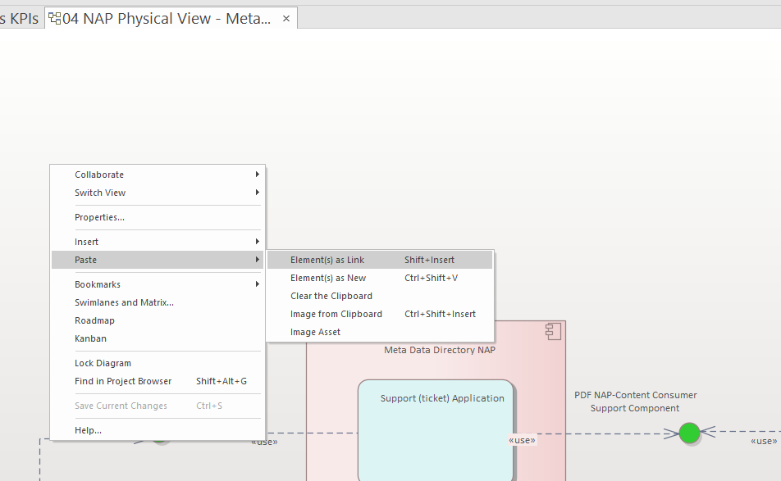 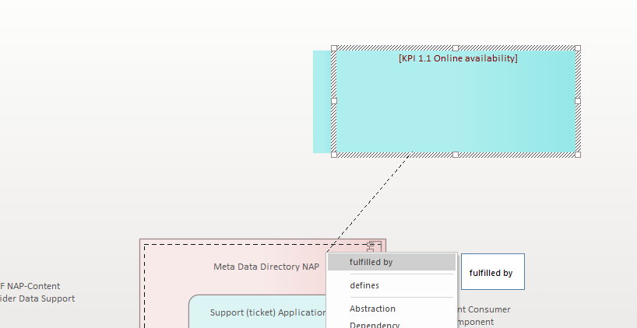 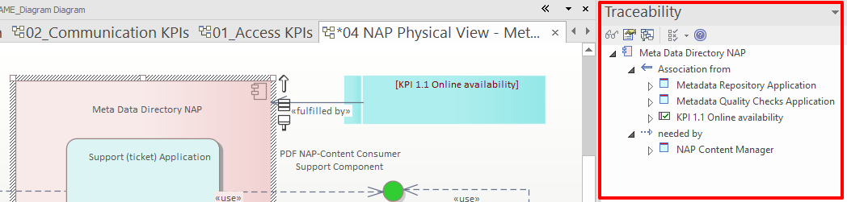

Figure 3 process of linking the KPI to the NRA object(s)

# Updating the KPIs

* For KPIs existing in the previous version (checked by KPI ID)
  1. Check if the KPI definition/name and minimal interoperability changed in the new NLKF (in contrast to the NRA KPI)
  2. Change the relevant parts of the NRA KPI
  3. Inspect all objects, find those affected by change and:
     + Map/unmap them to/from the NRA KPI
     + Modify definition of affected NRA objects (not necessarily mapped)
  4. Update the version of the changed KPI and any other changed object to the current date (e.g., 20240812)
* For KPIs NOT existing in the previous version (checked by KPI ID)
  1. Follow the procedure described in the chapters:
     + Modelling of the NLKF KPI as NRA KPIs and
     + Mapping NRA KPIs